Network Devices in a Home WiFi Setup

- Main Functions and Typical Ports

The table below lists the main purpose of each device and the physical ports/interfaces commonly found on it.
Device | Main Function | Typical Ports / Interfaces
Switch | Connects multiple wired devices in the same LAN and forwards Ethernet frames to the correct device. | Ethernet LAN ports (RJ-45), uplink/SFP on some models, console/management port on managed switches, power.
Router | Connects different networks, usually the home LAN to the Internet, and routes IP packets. Home routers often also provide DHCP and NAT. | WAN/Internet Ethernet port, LAN Ethernet ports, power, USB on some models, console on enterprise routers, Wi-Fi antennas on wireless routers.
Hub | Connects Ethernet devices but repeats incoming data to every port. It does not intelligently choose the destination port. | Multiple Ethernet (RJ-45) ports and power.
Firewall | Filters incoming and outgoing traffic according to security rules and helps block unauthorized access. | WAN and LAN Ethernet ports; management/console ports on dedicated firewall appliances; power.
Access Point | Provides wireless Wi-Fi access and bridges wireless devices to the wired LAN. | Ethernet/PoE port, power input when PoE is not used, built-in or external antennas; console/management interface on some enterprise APs.

- Label Three Network Devices and Their Ports

The following digital diagram labels a router, switch, and wireless access point and marks their common Ethernet, console/management, power, and antenna connections.
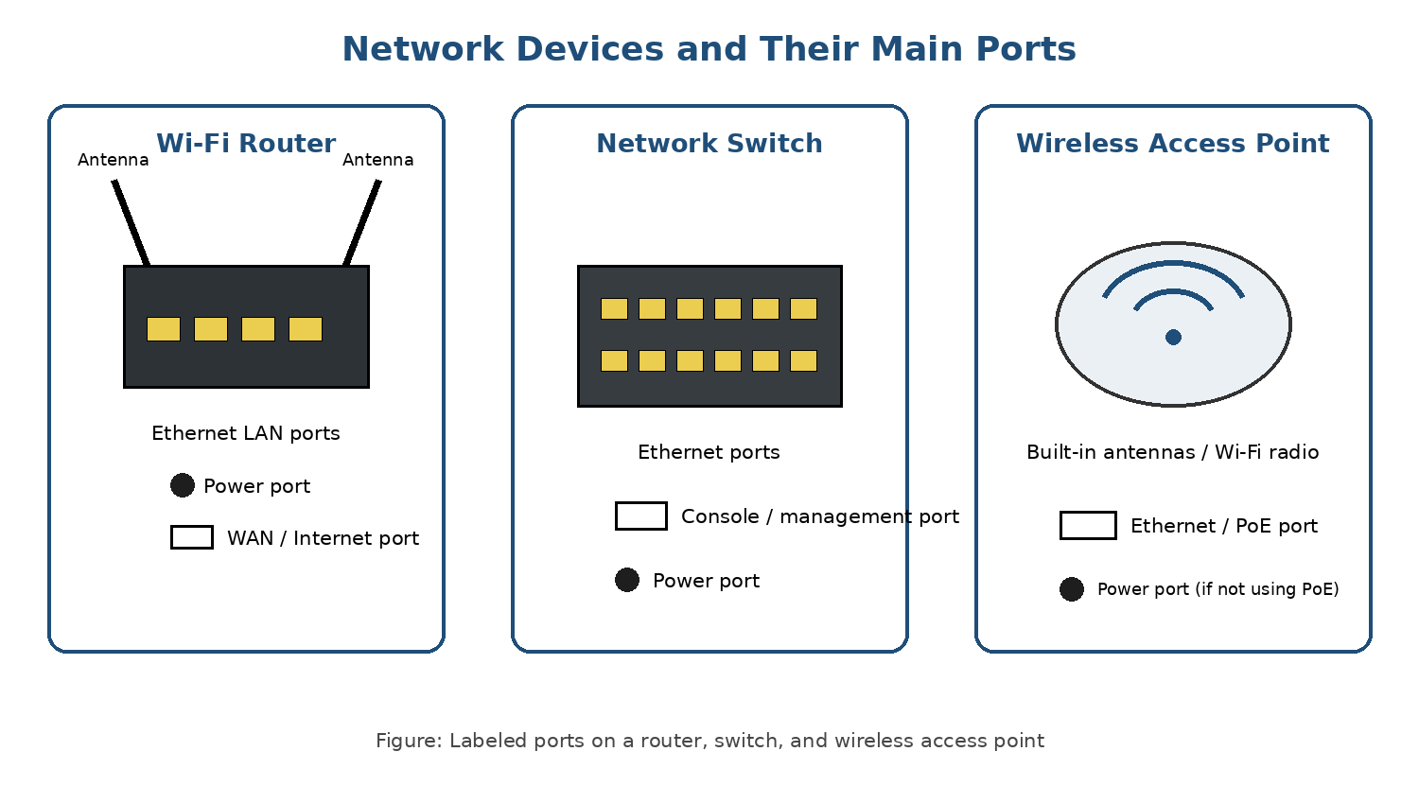
Screenshot/Diagram 1: Network devices with labeled ports

- Example: Using Instagram

When I open Instagram on my phone, the access point provides the Wi-Fi connection between my phone and the local network. The router then forwards my Internet traffic from the home network toward Instagram's servers. A firewall checks the traffic according to security rules and helps block unwanted connections. If wired devices are present, a switch can connect them to the same local network.

- College WiFi Is Slow and Sometimes Disconnects

One possible reason is that a single access point is serving too many students or does not provide enough coverage for the whole area. When many phones and laptops connect to the same access point, users may experience low speed, weak signal, or disconnections. Upgrading to a newer, higher-capacity access point and placing enough access points around the college can improve coverage and allow more devices to connect efficiently. If the Wi-Fi signal is strong but the network is still slow, the college should also check whether the switch uplinks or router/Internet connection are overloaded.

Conclusion
Switches, routers, hubs, firewalls, and access points perform different jobs in a network. The router connects networks, the switch connects LAN devices, the access point provides Wi-Fi, the firewall protects traffic, and a hub simply repeats traffic. Choosing devices with suitable capacity and coverage helps provide a faster and more reliable Wi-Fi network.

